Statement of the Business Users Constituency, regarding the Domain Tasting PDP, November – 2007
Background
On 31 October 2007, the GNSO Council launched a Policy Development Process (PDP) on domain tasting based upon the Final Outcomes Report of the ad hoc group on Domain Tasting and the ICANN Staff’s prior Issues Report on Domain Tasting.

The BC provides this statement in accordance with Council’s request for Constituency Impact Statements by 5 December 2007.

Summary
Domain tasting, the practice whereby would-be registrants leverage the 5-day Add Grace Period (AGP) to register domain names free of charge and test their value before deciding whether or not to keep them, is an unforeseen abuse of the AGP. Domain tasting, as is evident from the Verisign .COM monthly add/drop reports, now makes up the majority of domain transactions. While tasting appears to have led to an increase in the number of registered domain names, we believe that the practice is unfair, abusive, and contrary to our collective goals of creating a fair and open Internet that encourages competition and delivers all users relevant and tailored experiences.

Furthermore, based upon the Final Outcomes Report of the ad hoc group on Domain Tasting, we believe that the current practice benefits only a small number of registrars and registrants while causing harm to the vast majority of Internet Users. As such, the BC encourages and supports policy reform aimed at curbing abusive domain name tasting. In line with this, we recommend a new policy that either removes the AGP completely, or substantially changes the economics associated with this grace period so that one cannot commercially “test” large quantities of names for free.

Statement
As demonstrated by the Final Outcomes Report and other research performed to date, domain tasting is harmful and is an unfair business practice. Since accredited registrars have the unique ability to add and drop domains quickly and easily, the abuse of the AGP and the greatest volume of domain tasting is generally practiced by a select few domain name registrars and/or their customers. Since ICANN Staff believes these registrars are operating within the guidelines of the RAA, despite fairly clear language apparently to the contrary, they do not face any repercussions for participating in domain name tasting. Immediate corrective action needs to be taken to address the AGP policy and rectify the current problem which has been ongoing and rapidly expanding for more than two years.

Domain tasting is the practice whereby domain names are “tested” over the 5-day AGP. Valuable domains typically are not deleted during the AGP and thus show up as new registrations. Thus, conversation about domain tasting often leads to a conversation about cybersquatting and its subsequent harms such as trademark infringement, customer confusion and other fraudulent activities. The BC understands that analyzing the impact of domain tasting is inherently problematic since the harms it causes are associated with domain name registrations outside of the AGP. Yet there is no doubt that the increase in domain tasting activity directly correlates to the increase in domain registrations over the past several years. Far too many of those registrations are obviously infringing or otherwise in bad faith, to the profit of registrars and registries, and detriment of everyone else in the internet community.

Domain tasting has largely been confined to the .com TLD to date, leading to some 70 million current registrations, a large portion of which were part of a commercial tasting scheme and are blatantly cybersquatting. The BC fears that if the practice goes unchecked, the same experience will occur in other gTLDs. Indeed we have noticed similar problems in various ccTLDs already.

While the BC recognizes the difficulty in quantifying the negative impacts of tasting and tasted domains, it is evident to the BC that tasting is problematic for the following reasons:

- The most active domain name tasters are concentrated within a small group of accredited registrars, which have been identified in Verisign’s April 2007 .COM registry report (see below graph). Yet this graph may not capture some of the most voluminous tasters, who have obtained numerous registrar accreditations and thus are able to spread their activity amongst those separately accredited entities.

The AGP provides domain name registrars with an unfair competitive advantage over all other potential registrants since they have the technological capability to quickly add, drop, and identify names of value without incurring any cost, whether on their own accounts or on behalf of their customers. Domain tasters are able to register very large numbers, in some cases tens of millions, of names with no risk. They only incur cost of those names which apparently will deliver a positive ROI over the paid registration period (usually one year, but some registrars are offering monthly registrations).

A practice that allows for the testing and subsequent return of non-profitable purchases is unheard of in nearly every other marketplace. The BC believes we must advance domain name policies so that they are more closely aligned with those of other marketplaces.

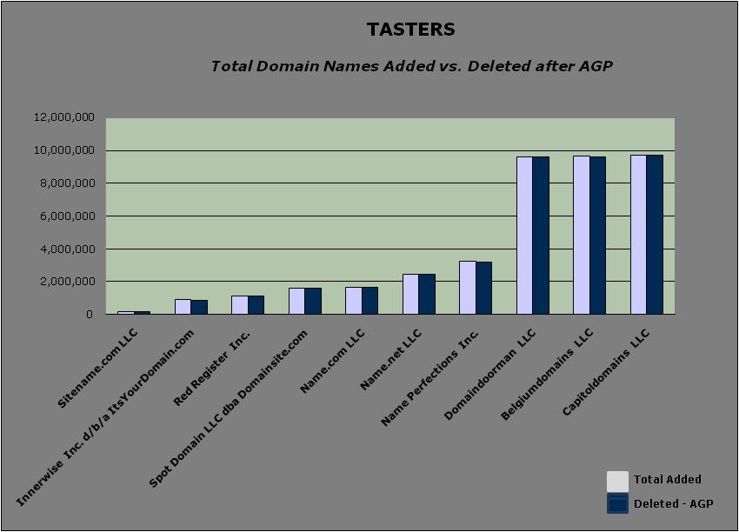Figure. Created from April 2007 .COM report provided by VeriSign.

- Domain tasting has led to an environment where tens of millions of domain names are caught up in the 5-day AGP at any given time. Because so many domain names are being added and dropped on a regular basis, domain name tasting has led to restricted choice as interested parties including individual registrants, small business, and corporations often find that the names they want are unavailable.

- Examining domain names that are owned by the serial domain tasters noted in Figure 2 demonstrates that tasters are registering names to monetize traffic via PPC advertising. The BC recognizes that the practice of domain name monetization is not illegal, but asserts that the combination of tasting and monetization has created an Internet environment that is counterproductive to providing all users with relevant experiences, and conducive to rampant cybersquatting.

There is no doubt that the large tasters are utilizing domains that correlate to well-known brands, as such domains generally garner more traffic than non-branded domains, since they are backed by advertising and consumer trust. The total number of domain names registered is directly correlated to the rise of domain tasting. The large number of domain names that have been registered to profit from the practice of direct navigation has created customer confusion and an increase in trademark infringement.

As noted previously, it is difficult to find concrete proof that tasting is connected to these issues since domain names that impact consumers and cause brand harm are those which garner traffic and are attractive registrations beyond the AGP. That said, the harm created by domain name tasting is aptly demonstrated simply by typing in any variation of a brand, group, event, or nearly any combination of characters and numbers into a browser bar. More often than not, these Web sites deliver users with links to irrelevant content, to relevant parties that are competitors of the brand in question and/or to advertising of the infringed brand owner itself.

For example:

Samesclub.com - REGISTRAR - CAPITOLDOMAINS, LLC – 11.12.07
mycokerewatds.com – REGISTRAR – CAPITOLDOMAINS, LLC – 11.12.07

Again, it is difficult to be certain whether these names that deliver unexpected content were the result of domain tasting. These examples have been included, however, since they are connected to registrars who are among the most active domain tasters and they both receive thousands of visitors per month. There are thousands of other examples known to BC members.

RECOMMENDATIONS

We propose the following steps, in order of preference, based upon the BC’s position that domain tasting is counterproductive, problematic and unfair:

- Eliminate the AGP, but provide accredited registrars with the ability to test their domain fulfillment systems via a number of test adds/changes/deletes without cost. The number agreed upon should be derived from research on registrars that are not involved in domain tasting. Or,
- Change the economics of domain tasting – The portion of every domain registration fee due to ICANN should be non-refundable, and excess deletes (based on an agreed ratio in a given time period) should result in full payment of all registration fees for the period.

Update 31 March 2008

The Business Constituency supports the motion released for
public comment by the GNSO Council. It is consistent with the existing BC
position on this issue: that either the AGP should be dropped altogether,
or we should have a combination of both a non-refundable 'ICANN fee' as
proposed by the ICANN Board, and 'excess delete fees' as proposed in the
GNSO motion. Hopefully that combination would severely curtail commercial
domain tasting, and resultant cybersquatting and other harm to the internet
community.

